**Let’s get snack healthy**

Dear guest,

To safeguard you from spread of covid, we aren’t providing breakfast.

But we have bought covid friendly and snack healthy food for you.

Basket including

* Quaker Oats ; Oatmeal Cookies; Protein Bars; Fruit Salad

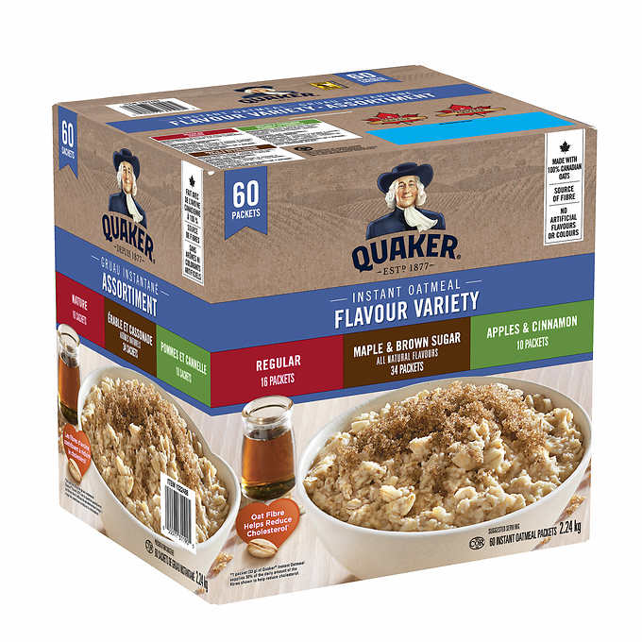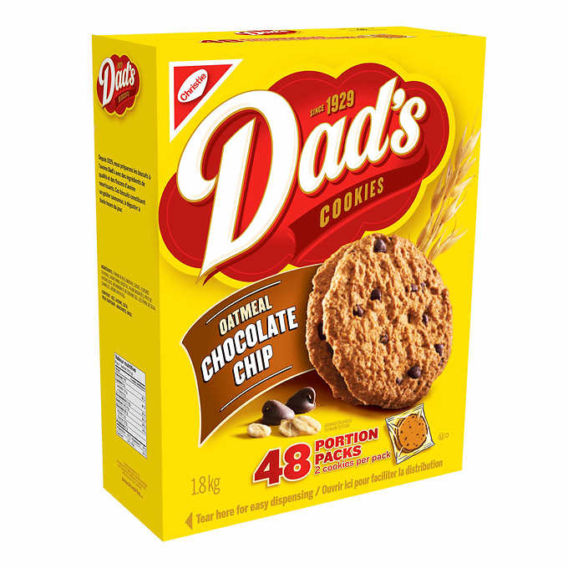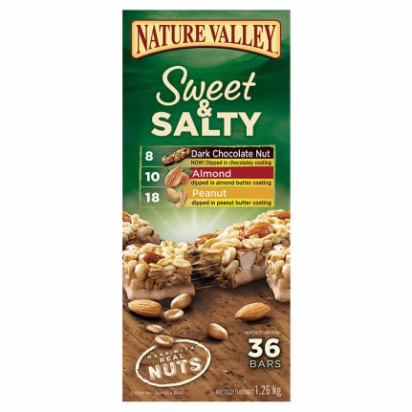

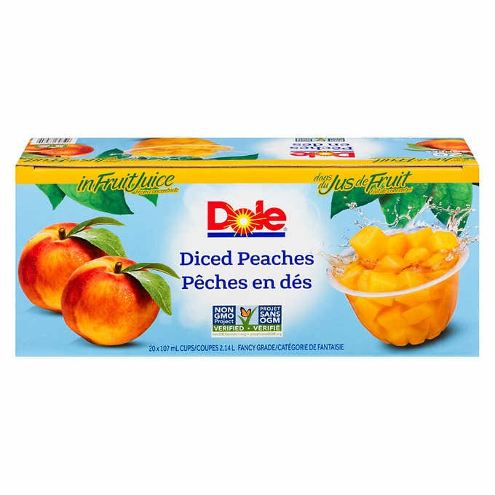

**\*\*\*Paid snack pack\*\*\***

|  |  |  |  |
| --- | --- | --- | --- |
| Product | Benefit | Price | Quantity |
| *Quaker oats* | Rich in antioxidants and beta-glucan | $11.99 | 60 packs |
| *Oatmeal choc chip cookies* | Rich in carbs, fiber, protein and minerals | $11.49 | 48 packs |
| *Sweet n salty bars* | Rich in Protein, vitamin and minerals.  Contains nuts | $ 11.49 | 36 packs |
| *Dole fruit salad* | Source of fiber an healthy fats | $ 11.89 | 20 packs |

## Guest reviews card

Front desk Housekeeping overall stay

**\* \*** **------**

**+ +**

**Comments** -----------------------------------------------------------

***Instagram*** - @happydayinn

***Email*** - marketing@happydayinn.com

Dear Guest,

We would like to thank you for choosing happy day inn for your stay. We really hope that we are able to fulfill all your requests and requirements made prior to your stay and that you enjoyed your stay here.

If you have any suggestions for us, please feel free to write us back.

Thank you

***Please click on the hyperlink to provide us with your reviews.***

[***happy day inn/Google reviews***](https://www.google.com/travel/hotels/entity/CgoIm-bB4cnkxNlvEAE/reviews?g2lb=2502548%2C4258168%2C4270442%2C4306835%2C4317915%2C4328159%2C4371334%2C4401769%2C4419364%2C4463263%2C4463666%2C4482194%2C4482438%2C4488304%2C4491423%2C4495810%2C4270859%2C4284970%2C4291517&hl=en-CA&gl=ca&un=1&rp=EJvmweHJ5MTZbxCb5sHhyeTE2W84AkAASAHAAQI&ictx=1&sa=X&ved=0CAAQ5JsGahcKEwjQt_X3-LzuAhUAAAAAHQAAAAAQAw&utm_campaign=sharing&utm_medium=link&utm_source=htls&hrf=IgNDQUQqFgoHCOUPEAEYHxIHCOUPEAIYARgBIAKCASUweDU0ODY3N2MwZmRkYjcwN2Q6MHg2ZmIzMTMyNDljMzA3MzFimgEnGiUweDU0ODY3N2MwZmRkYjcwN2Q6MHg2ZmIzMTMyNDljMzA3MzFi)

Dear partner,

I would like to inform you about an update at our motel. We are starting a snack pack for our customers. I would be grateful if you could post it on our websites.

Regards,

